**Madcap Flare to Amazon S3 - Process**

We have created a bridge between Madcap Flare and Amazon S3 by publishing the files to the local file system.

**The folder naming S3 is containing the data folder and two .bat files.**

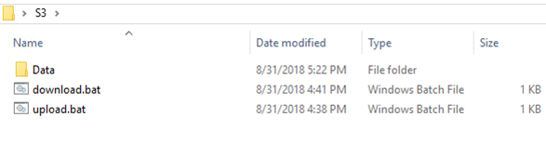

We have used the “Data” folder to collect the files from madcap flare. The “download.bat” and “upload.bat” file will help us in pushing the published files from “Data” folder to “S3”. Once the files will be published inside the “Data” folder from Madcap Flare, you just need to run the file “upload.bat” and it will push all the files inside Amazon S3 drive. Similarly, “download.bat” file will be going to work in an opposite manner.

**Download.bat** – This file will download the files that are stored inside Amazon S3 drive. Here is the command that is used to create this bat file.

cd C:\Program Files\Amazon\AWSCLI

aws s3 sync s3://testing-s3-vikas C:\Users\user1\Desktop\S3\Data\. --delete

**Upload.bat** – This file will upload the files that are stored inside Amazon S3 drive. Here is the command that is used to create this upload bat file.

cd C:\Program Files\Amazon\AWSCLI

aws s3 sync C:\Users\user1\Desktop\S3\Data\. s3://testing-s3-vikas

**Madcap Flare**

Inside madcap flare, under project organizer you will need to set up a destination inside Destinations folder.

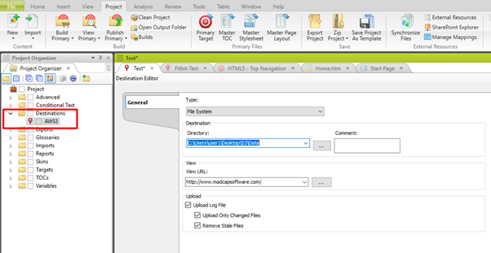

Once the destination is set-up, the next step is to select the type, directory and URL.

Here, we have provided the local path under directory and it is connecting with the S3 folder from where we will be pushing the files into Amazon S3 drive.

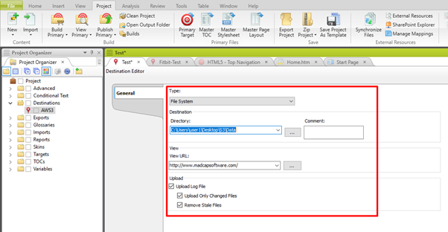

After setting up the destination, we just need to publish the files from Madcap Flare.

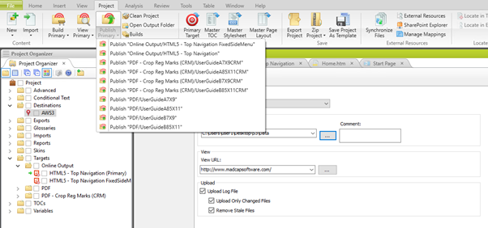

Once the files will be published, you will just need to go to the local file system folder that had been created naming “S3”. From here onwards, the files can be pushed to S3 server by clicking on upload.bat file.